Christmas letter 2016
Don Bosco Home care & Kindergarten

Geachte Wilde Ganzen en donateurs van SSCR,

Vanuit Don Bosco Kindergarten wensen we u allen een Gezegend Kerstfeest en een Gelukkig 2017 toe. Dankzij u is het leven van veel kinderen hier sterk verbeterd, we zien ze opbloeien van de zorg en aandacht die ze krijgen. Hartelijk dank dat u dit mogelijk heeft gemaakt.

The children and staff from Don Bosco Kindergarten in Sihanoukville wish you and your family a Merry Christmas and Happy New Year!
Kindergarten was opened in March of this year. A beautiful building. We thought of ways to inform parents about our services, but the news had already spread. We now have 20 children in Kindergarten and 12 in the nursery.

The students Child care are happy to live in Kindergarten, a light and fresh place with lots of space.

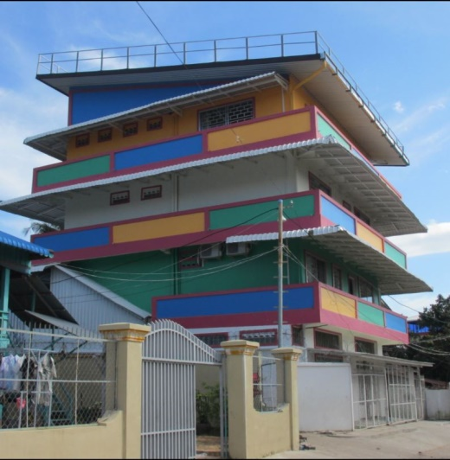

The first 6 months were hectic. Most of the children played in the street all day and did as they pleased. They had to get used to the rules and routines in Kindergarten. No fighting, a rest after lunch and participation in lessons. The results are amazing. They now fall asleep at the table when lunch is a little late.
Hopefully these individual stories will give you an impression of our work and progress:

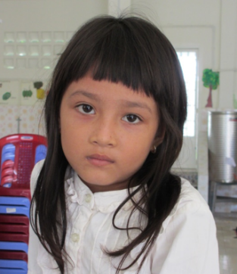
Samnang (7) is the first student that “graduated” from Kindergarten. Six months ago, she held a pencil for the first time, and now she does well in Primary School. She sometimes comes to Kindergarten after school to play with her friends and to have dinner with us.
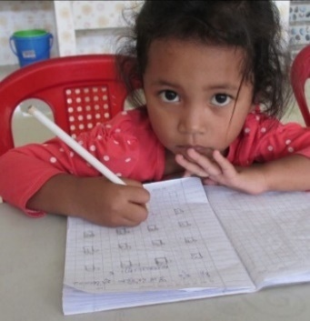
Lyhong (4) is our Lady Einstein. She knows her ABC, can count to 20, name all colors and shapes and she knows the names of many animals. All of it in Khmer and in English.

Satiya’s (almost 5) mother came with her son 4 months ago. He was sent away from two other school because of his behavior. She asked us if he could please have a try-out for a couple of days. She would leave her telephone number so we could ask her to come and pick him up any time if he was causing problems. Satiya behaves a little different. He sometimes repeats a word or a name 20-30 times, or he has to get up and run around for a minute. No problem for us nor for the other children. Satiya even has a real friend in school.

At least two times a week we have to call Kim Lang’s (3) parents and ask them to pick her up from school, because they forget about her. They have a busy vegetable shop in the market and five children. Kim Lang is the youngest, she used to stay in the market all day. She is a tomboy. Panha, a boy her age, is her best friend. They imitate each other when they play. When one jumps from a chair, the other soon will follow. For lunch and dinner, they always share a table. They have a nice chat and toast with their cups of water.

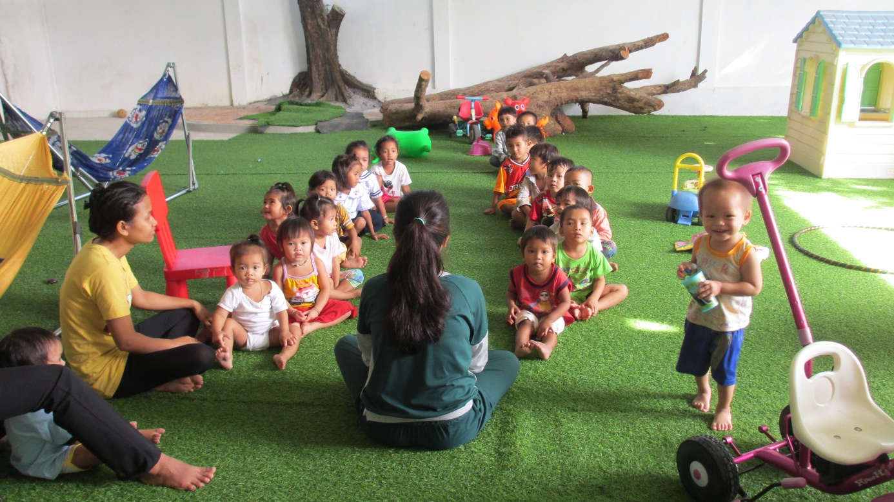
Every morning we start with a morning talk and some exercises in the playground.

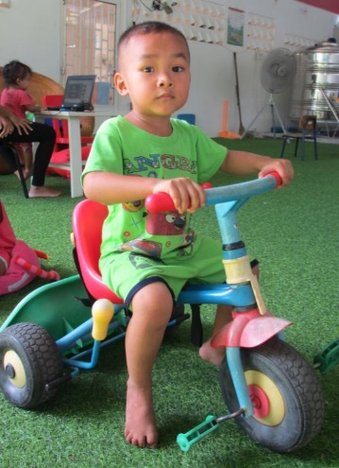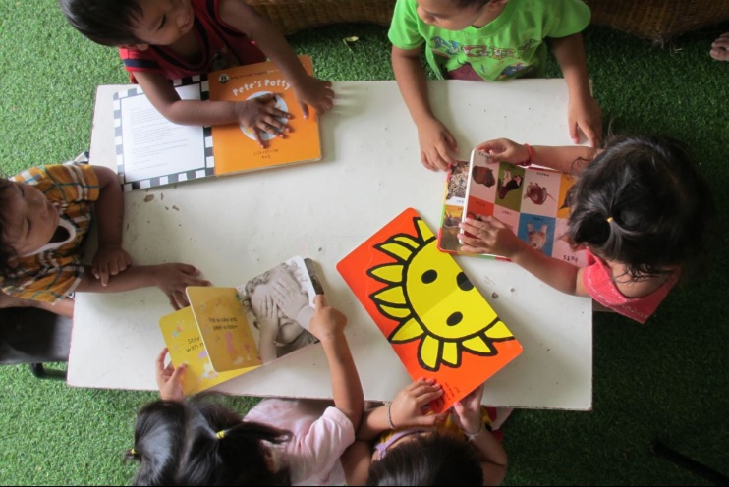

In October the first four students for the Child care course enrolled. They have extra lessons in for instance child development, the importance of play and health care. The girls do very well, they are happy and cheerful and their ability to communicate in English is improving rapidly.
Dentist Svend Holm from Denmark works as a volunteer in the Hotel School for five years. Two times per year, he comes to Sihanoukville treat students and teachers. We asked Svend to have a look at the children in Kindergarten, because many of them suffer from serious tooth decay, even at the age of 2 or 3. We hope he will become our regular school dentist, together we can promote tooth care with children and parents. In December, the students Child care had a very nice lesson in Svend’s practice. Some of them had never had been to a dentist before. The lessons resulted in painful but necessary appointments for two girls.

It is very rewarding to see how the children flourish. Besides the physical care we offer, we prepare them for Primary School by teaching them basic knowledge and social skills. Without this pre-school training, our target group is likely to end up with little education. In public schools, classes can contain 40-50 students. Little chance that the teacher will give a student extra attention.
Our Don Bosco Kindergarten was started thank to the outstanding love and dedication of Marileen van der Aa. She is dedicating one year of her life and she came to stay with the children since April 2016. She took care to prepare all details for implementing such beautiful project, changing the life of many children.

Thanks very much to all volunteers, benefactors and friends for supporting the children and giving them a chance for a better future.

MERRY CHRISTMAS AND HAPPY NEW YEAR

Brother Roberto
The Don Bosco Homecare & Kindergarten Team
December 2016, Sihanoukville, Cambodia

