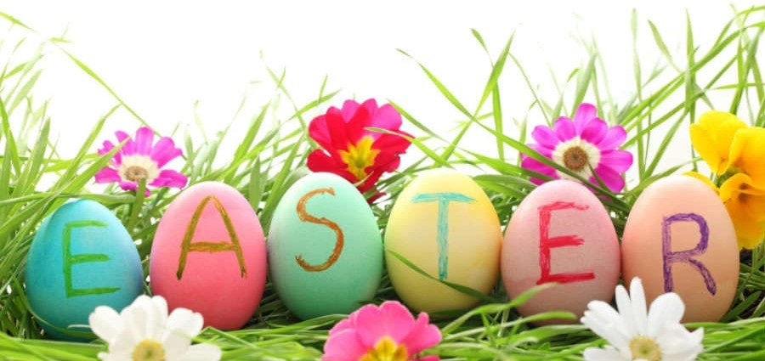
Happy Easter 2018

The Don Bosco Children Fund, Cambodia would like to extend their best wishes to you and your loved ones in this joyous Easter season.
Dear Friends and Benefactors,
At this important time of the year in the life of the Catholic Church, we would like to thank you all for your generosity in supporting the young and vulnerable children of Cambodia. These children face abandonment, lack of food and no access to education but with your continuing support, the Don Bosco Children Fund are working hard to change this.
In Easter time we remember the sacrifice that God made for us but also his loving nature as he sent his only son down to earth to be crucified for the forgiveness of our sins. Most importantly, however, we celebrate the mystery of Jesus’ resurrection; it is in this vein that we would like to recognize the love and care that you all show to the children and also the sacrifices that you make each day to give these children a better life. The Children and the DBCF are very grateful.

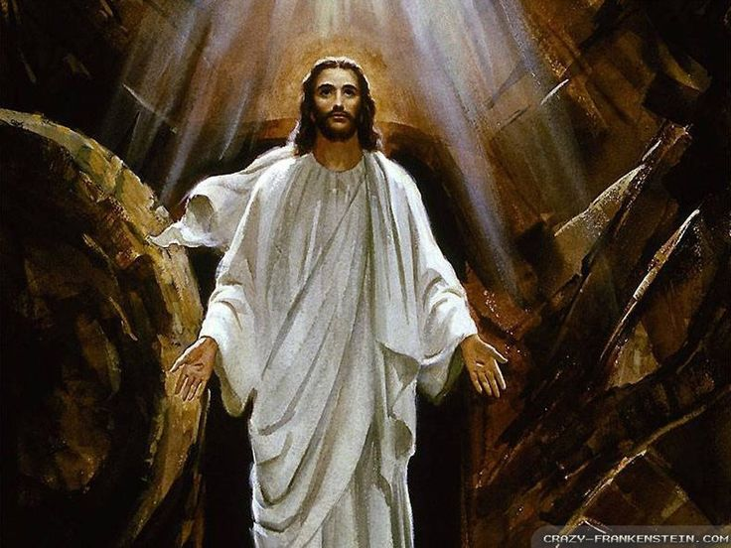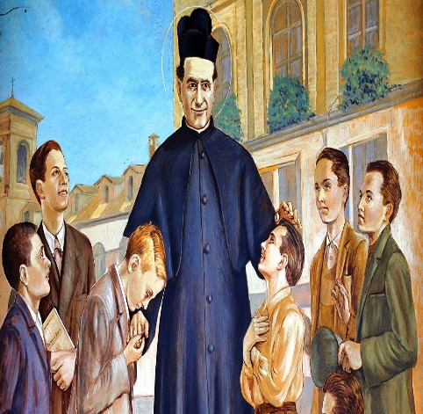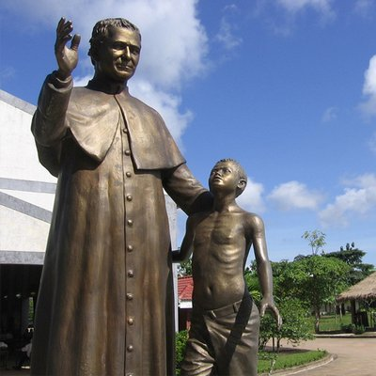

The Don Bosco Children Fund in Cambodia is divided into five branches: Phnom Penh, Sihanoukville, Kep, Battambang and Poipet. Each of the branches are in close contact with the children and sponsors from their area. Despite being split geographically, the DBCF are united by the same ideals and the same vision for the welfare of the children under our care in the spirit of Saint John Bosco, our patron. Each branch are in regular contact with the other branches across the country so that we can share ideas and information with the aim of improving our service for the children.
We at the DBCF believe that there is always more we can do to aid the plight of those in need. That is why we are asking for you, our friends and benefactors, to spread the word about the Don Bosco Children Fund and we ask that if you know anyone who would be interested in getting involved with the children fund then please tell them to get in contact with us as soon as possible – together we can improve the lives of the children under our care.
It goes without saying that without you, our supporters, it would not be possible for the Don Bosco Children Fund to work in Cambodia so we are most grateful for keeping us going and therefore giving the children a chance at a better future. Thank you, as always for your continuing support.
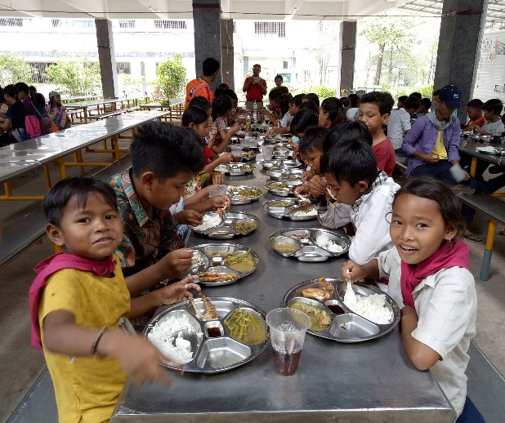

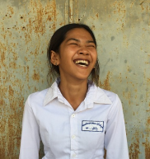
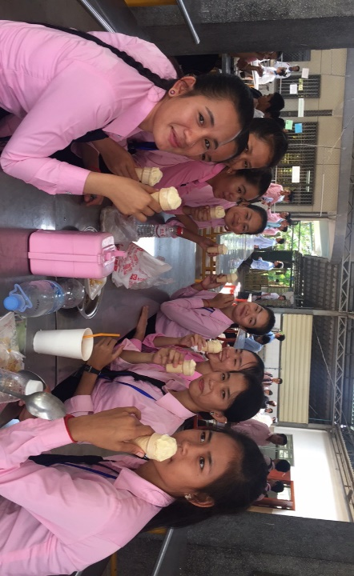

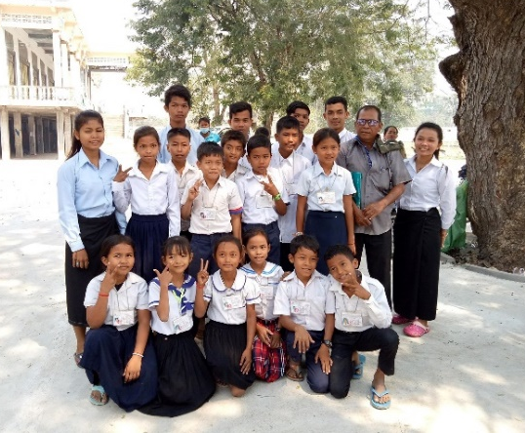

Easter is a time of new beginnings and by continuing to work together, we believe that we can give the children a new start and a brighter future; something which is of the highest value.
Wishing you a happy and blessed Easter.
The Don Bosco Children Fund,
Cambodia.

